**Assignment -2**

Data Analytics

|  |  |
| --- | --- |
| Assignment Date | 11 October 2022 |
| Student Name | Mr.B.Hariharan |
| Student Roll Number | 19ITA20 |
| Maximum Marks | 2 Marks |

**Question-1:**

Sales By Customer.

|  |
| --- |
| **Solution:** |

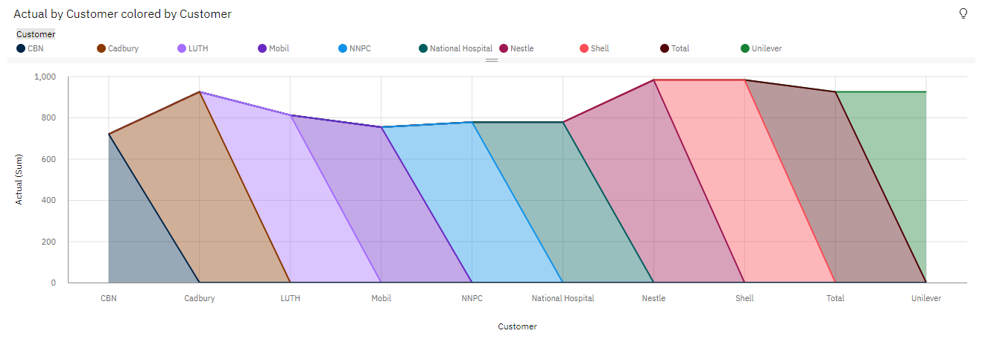

**Question-2:**

Sales By Location.

|  |
| --- |
| **Solution:** |

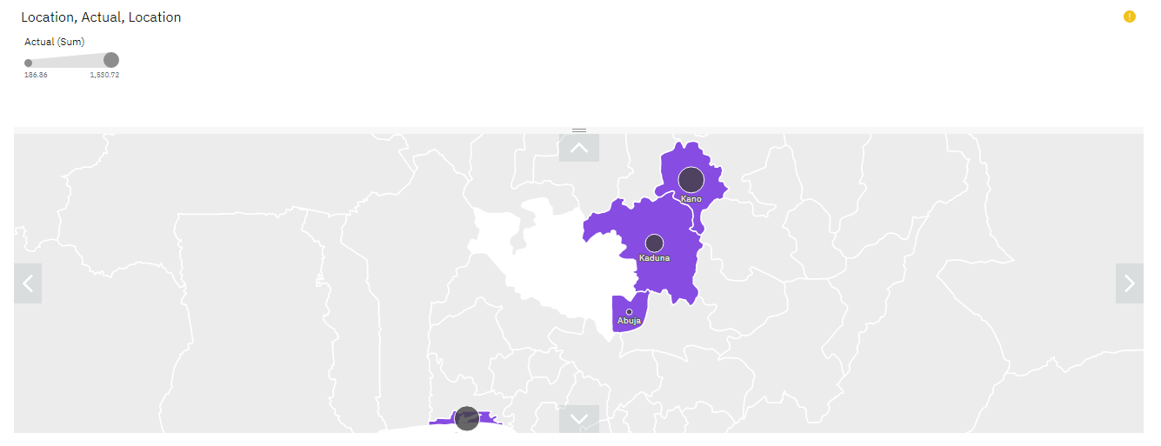

**Question-3:**

Sales By Sales Representative.

|  |
| --- |
| **Solution:** |

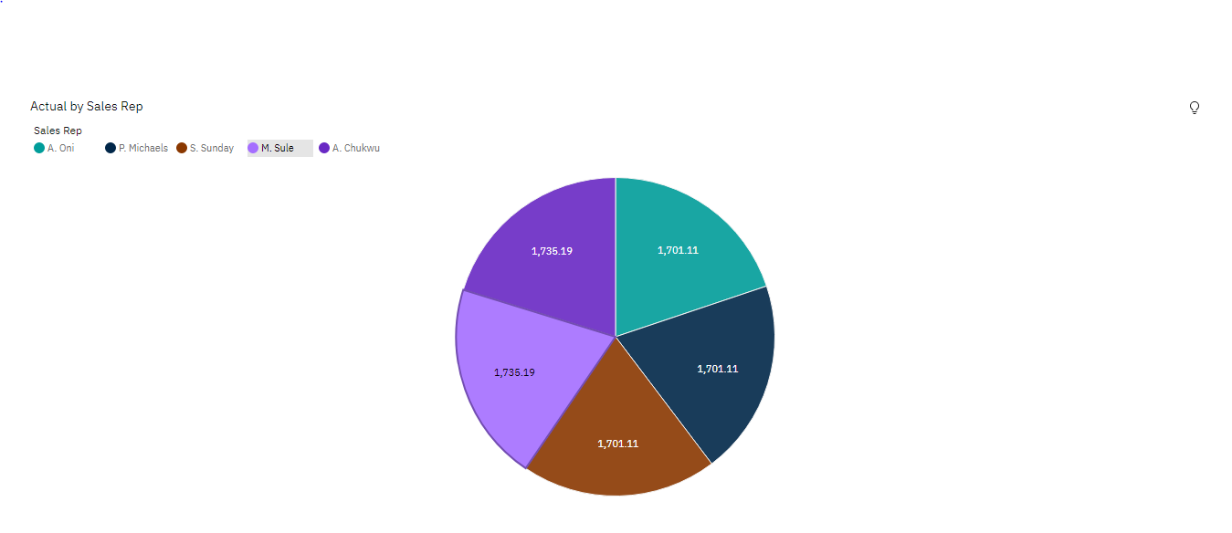

**Question-4:**

Received Inventory From Supplier.

|  |
| --- |
| **Solution:** |

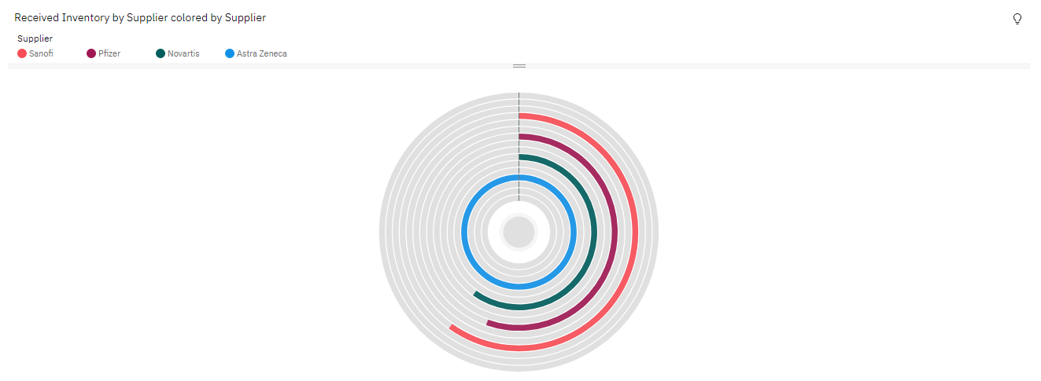

**Question-5:**

Inventory Stock for Warehouse Locations.

|  |
| --- |
| **Solution:** |

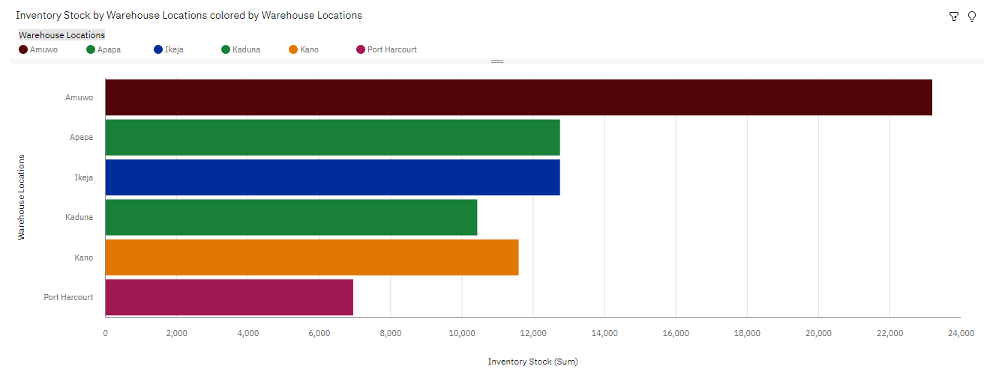

**Question-6:**

Sales Trend.

|  |
| --- |
| **Solution:** |
| **6.PNG** |

\

**Question-7:**

Monthly Sales.

|  |
| --- |
| **Solution:**  **7.PNG** |
| **Question-8:**  Actual and Received Inventory by Month.  **Solution:**  8.PNG   |  | | --- | |  | |